# Software Engineering Group Project

# Meeting Minutes

Date: Jan-17th, 2019

1. 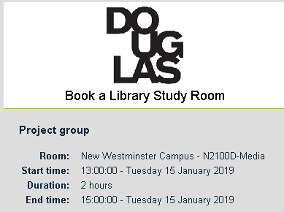Agenda

Regular meeting for group project: integration the project proposal for CSIS 3275, Software Engineering course at 13:00 on 17th at location.

1. Attendants

Daniel Ahn (Seongku Ahn), Ankit, Twinkle

1. Last issues
   1. Prepare the project proposal.
   2. R&R (Role and Responsibilities):
2. Open issues
   1. Review the proposal document and add more information  
       - Use cases   
       - Printing the documents
   2. Make the account for Trello and Github
3. Next steps
   1. The introduction of project environment: platform and toolset
   2. How to code and build the application. Uploading the code to Github.
   3. Details of each component
4. Submitter

Minutes submitted by: Daniel Ahn (Seongku Ahn)